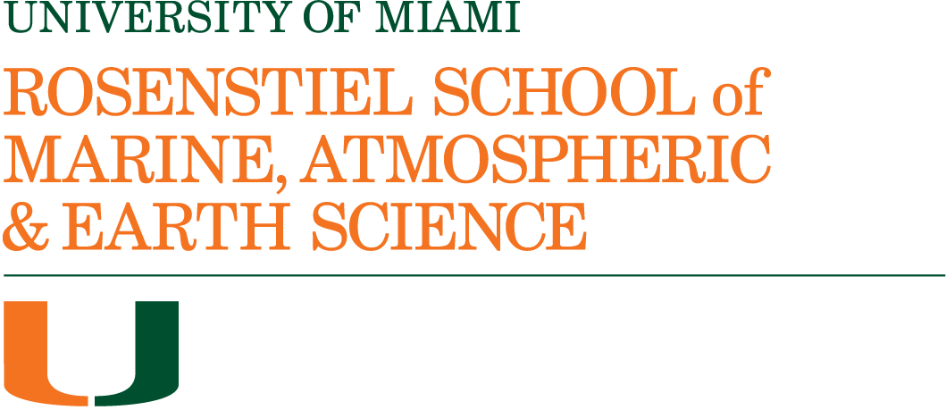

Biography
Ben Kirtman, Ph.D.
Professor, Department of Atmospheric Sciences
William R Middelthon Endowed Chair of Earth Sciences
Director, NOAA Cooperative Institute for Marine and Atmospheric Studies (CIMAS)
Deputy Director, Institute for Data Science and Computing (IDSC)

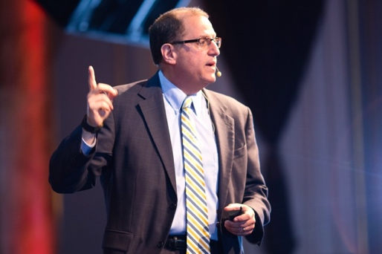
Professor Benjamin Kirtman received his BS in Applied Mathematics from the University of California-San Diego in 1987, and his MS and Ph.D. in 1992 from the University of Maryland-College Park. From 1993-2002, Dr. Kirtman was a research scientist with the Center for Ocean-Land-Atmosphere Studies and in 2002 joined the faculty of George Mason University as a tenured Associate Professor. In 2007, Dr. Kirtman moved to the University of Miami Rosenstiel School as a full professor of meteorology and physical oceanography (now atmospheric sciences), is the Director of the Cooperative Institute for Marine and Atmospheric Studies (CIMAS) and serves as the Deputy Director for the Institute for Data Science and Computing. Dr. Kirtman is also a 2017-18 recipient of the UM Provost’s Award for Scholarly Activity and was awarded the Department of Atmospheric Sciences undergraduate teaching award in 2016, 2017 and 2018. In 2018, Dr. Kirtman was elected as a Fellow in the American Meteorological Society (AMS). Effective 1 January 2023 Dr. Kirtman is the inaugural William R Middlethon Endowed Chair of Earth Sciences.
In 2011, he was appointed Associate Dean of Research for the Rosenstiel School. In 2008, Professor Kirtman received the Distinguished Alumnus Award from the Department of
Atmospheric and Oceanic Science at the University of Maryland. Dr. Kirtman was also awarded the Stony Brook University School of Marine and Atmospheric Science Robert D. Cess Distinguished Lecture in Recognition of Outstanding Contributions to Atmospheric Sciences in 2018.

Internationally, Dr. Kirtman has enjoyed a leadership role in the World Climate Research Program (WCRP) seasonal to-interannual prediction activities. In particular, he has chaired the
International Clivar Working Group on Seasonal to Interannual Prediction (WGSIP), and the WCRP Task Force for Seasonal Prediction (TFSP). Dr. Kirtman was a coordinating lead author for the Intergovenmental Panel on Climate Change (IPCC) working group one – the Scientific Basis.

Professor Kirtman was an Executive Editor of Climate Dynamics, is an Editor of the AMS journal Weather and Forecasting and was an Associate Editor of the American Geophysical Union Journal of Geophysical Research and has received numerous research grants from the National Science Foundation, Department of Energy, NOAA, NASA, and the Office of Naval Research, and he leads the North American Multi-Model Ensemble Prediction (NMME) Experiment. Professor Kirtman is the author and/or co-author of over 230 peer reviewed papers focused on understanding and predicting climate variability and change on time scales from days to decades.

